Spearman rank correlation: GBPUSD and AUDUSD
Method 02 / daily log returns / Alpari D1 full available history

Study setup
Logical pair: GBPUSD , AUDUSD
Broker symbols: GBPUSD_i , AUDUSD_i
Snapshot: 2026-11-03_majors_alpari_D1
Timeframe: D1
Matched return window: 1999-01-05 to 2026-11-02 (UTC bar dates)
Matched return count n: 7228
Dropped unfinished last bar dated 2026-11-03 UTC after a tick-volume check against the prior complete day.
Complete matched rows (CSV): GBPUSD-AUDUSD_Spearman_D1.csv
Complete matched rows (HTML table): GBPUSD-AUDUSD_Spearman_D1_data.html

Method carried forward
Spearman rho is Pearson correlation on the ranks of matched daily log returns of close, ln(close_t / close_t-1), in the broker quote direction. Ties use average ranks. Quotes are not inverted. rho is symmetric under swap of the two symbols. rho = 0 means no consistent rank-order link in this sample; it does not mean no link of any kind. The score is not a cause, not a lead, and not a trading signal. Daily rows are not independent draws, so the two-sided p-value and approximate Fisher interval are reported and treated as secondary to rho. Same-sample Pearson r is shown only as a side check; a large rho minus r gap can flag outliers or a non-straight link.

Results
Spearman rho: 0.515913
Two-sided p-value: 0
Approximate 95% Fisher interval: [0.498791, 0.532632]
Same-sample Pearson r: 0.539048
rho minus r: -0.023135

Conclusion
Over 7228 matched daily log-return rows for GBPUSD and AUDUSD (broker quote directions unchanged), Spearman rho is 0.5159 (positive, moderate rank-order association in this sample). Approximate 95% Fisher interval: [0.4988, 0.5326]. Same-sample Pearson r is 0.5390 (rho minus r = -0.0231). Two-sided p under the usual independent-ranks model is 0; that model does not match linked daily FX returns, so treat p as secondary. This does not establish cause, lead-lag, or a lasting trading rule.

Charts
Daily closes

Daily log returns
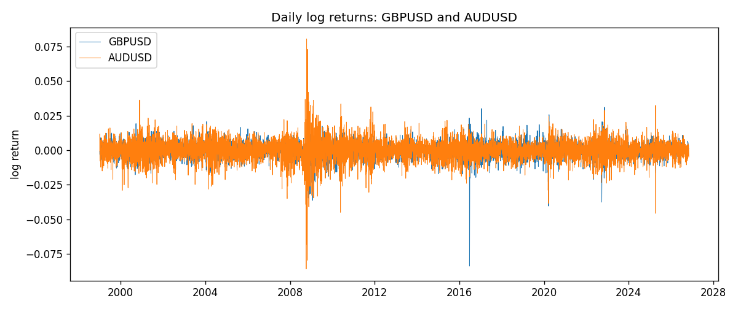
Log-return scatter
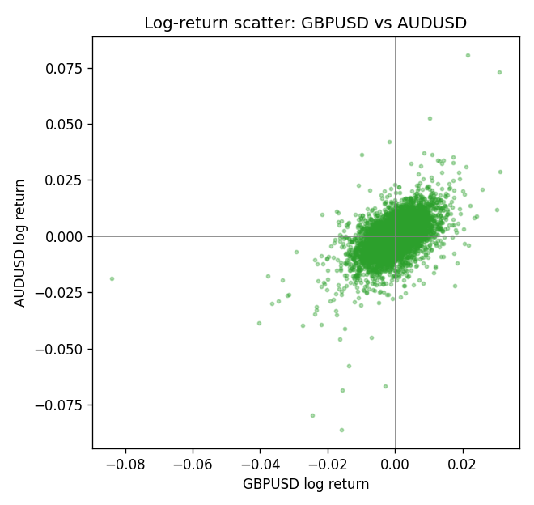
Rank-rank scatter
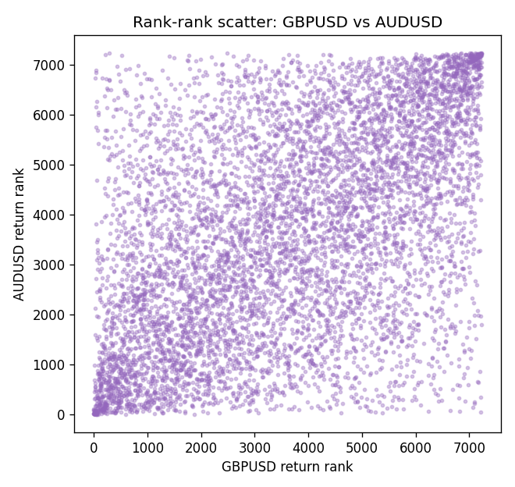

Data report
Every matched row that entered Spearman rho is stored in the sibling CSV named GBPUSD-AUDUSD_Spearman_D1.csv. That file is the complete data archive for redrawing charts. Embedding all rows as a Word table is impractical at this length; the Word file holds the column list, column summaries, and the first and last 15 matched rows.
Columns: time, GBPUSD_open, AUDUSD_open, GBPUSD_high, AUDUSD_high, GBPUSD_low, AUDUSD_low, GBPUSD_close, AUDUSD_close, GBPUSD_tick_volume, AUDUSD_tick_volume, GBPUSD_spread, AUDUSD_spread, GBPUSD_real_volume, AUDUSD_real_volume, GBPUSD_log_return, AUDUSD_log_return
Column summaries (matched calculation rows)
column | count | mean | std | min | 25% | 50% | 75% | max
GBPUSD_open | 7228 | 1.5166822 | 0.21834818 | 1.06854 | 1.3254025 | 1.51196 | 1.63237 | 2.1066
AUDUSD_open | 7228 | 0.75192541 | 0.13534725 | 0.4785 | 0.66102 | 0.7315 | 0.8091975 | 1.10284
GBPUSD_high | 7228 | 1.5229801 | 0.21891417 | 1.08366 | 1.3300275 | 1.518725 | 1.638825 | 2.1161
AUDUSD_high | 7228 | 0.75597511 | 0.13590934 | 0.4878 | 0.664695 | 0.734945 | 0.81552 | 1.10795
GBPUSD_low | 7228 | 1.5103473 | 0.21757706 | 1.03518 | 1.32009 | 1.50469 | 1.624985 | 2.0983
AUDUSD_low | 7228 | 0.74786335 | 0.13465689 | 0.4775 | 0.6577 | 0.72762 | 0.804475 | 1.0975
GBPUSD_close | 7228 | 1.5167386 | 0.2183035 | 1.06879 | 1.32568 | 1.51203 | 1.6324775 | 2.1065
AUDUSD_close | 7228 | 0.75196864 | 0.13532707 | 0.4786 | 0.6611875 | 0.731775 | 0.809315 | 1.10169
GBPUSD_tick_volume | 7228 | 94565.268 | 153330.81 | 62 | 9974.5 | 52775.5 | 91622.5 | 1273370
AUDUSD_tick_volume | 7228 | 77126.179 | 137934.11 | 109 | 5406 | 43250.5 | 71246.75 | 1234623
GBPUSD_spread | 7228 | 27.003182 | 19.183813 | 0 | 11 | 20 | 50 | 50
AUDUSD_spread | 7228 | 30.855562 | 16.875394 | 0 | 13 | 30 | 50 | 50
GBPUSD_real_volume | 7228 | 3.5428062e+09 | 8.4280615e+10 | 0 | 0 | 0 | 0 | 2.4038164e+12
AUDUSD_real_volume | 7228 | 5.2225089e+09 | 1.2514647e+11 | 0 | 0 | 0 | 0 | 3.811512e+12
GBPUSD_log_return | 7228 | -2.954e-05 | 0.0056473 | -0.08388241 | -0.00313242 | 3.002e-05 | 0.00317333 | 0.03112653
AUDUSD_log_return | 7228 | 1.629e-05 | 0.00754363 | -0.08602525 | -0.00386494 | 0.00027649 | 0.00415111 | 0.0806166
First 15 matched rows (selected columns)
time | GBPUSD_close | AUDUSD_close | GBPUSD_log_return | AUDUSD_log_return | GBPUSD_tick_volume | AUDUSD_tick_volume
1999-01-05 | 1.6547 | 0.6215 | -0.0028966287 | -0.00080418179 | 4645 | 1103
1999-01-06 | 1.6537 | 0.6289 | -0.00060452184 | 0.011836351 | 4729 | 1412
1999-01-07 | 1.6502 | 0.6345 | -0.002118709 | 0.0088650256 | 4858 | 1468
1999-01-08 | 1.6405 | 0.6347 | -0.0058954193 | 0.00031515916 | 5354 | 1225
1999-01-11 | 1.6312 | 0.6393 | -0.0056851331 | 0.0072213815 | 4080 | 1318
1999-01-12 | 1.6349 | 0.6362 | 0.0022657001 | -0.0048608485 | 5001 | 1908
1999-01-13 | 1.6499 | 0.6312 | 0.0091330396 | -0.0078902098 | 5730 | 1829
1999-01-14 | 1.6531 | 0.6295 | 0.0019376331 | -0.002696916 | 4902 | 1593
1999-01-15 | 1.6502 | 0.634 | -0.0017558204 | 0.007123101 | 6383 | 1604
1999-01-18 | 1.6522 | 0.6346 | 0.0012112405 | 0.00094592471 | 4357 | 1430
1999-01-19 | 1.6553 | 0.6392 | 0.0018745281 | 0.0072225153 | 4655 | 1733
1999-01-20 | 1.6472 | 0.64 | -0.0049053846 | 0.0012507819 | 4502 | 1901
1999-01-21 | 1.6524 | 0.6405 | 0.0031518998 | 0.00078094498 | 4609 | 1946
1999-01-22 | 1.6565 | 0.6327 | 0.0024781662 | -0.012252745 | 4230 | 1875
1999-01-25 | 1.6585 | 0.6302 | 0.0012066366 | -0.0039591468 | 3069 | 1413
Last 15 matched rows (selected columns)
time | GBPUSD_close | AUDUSD_close | GBPUSD_log_return | AUDUSD_log_return | GBPUSD_tick_volume | AUDUSD_tick_volume
2026-10-13 | 1.32534 | 0.69821 | 0.0036434319 | 0.0035007712 | 53930 | 34335
2026-10-14 | 1.31884 | 0.69715 | -0.0049164679 | -0.0015193215 | 64640 | 43650
2026-10-15 | 1.32757 | 0.69191 | 0.0065976411 | -0.0075447063 | 80461 | 50656
2026-10-16 | 1.33257 | 0.69426 | 0.0037592051 | 0.0033906408 | 65988 | 40991
2026-10-19 | 1.33024 | 0.6978 | -0.0017500314 | 0.0050859986 | 56543 | 37273
2026-10-20 | 1.3377 | 0.70022 | 0.0055923442 | 0.0034620426 | 58955 | 38736
2026-10-21 | 1.33937 | 0.70275 | 0.0012476328 | 0.0036066384 | 55613 | 36307
2026-10-22 | 1.33967 | 0.70186 | 0.00022396082 | -0.0012672558 | 64255 | 43496
2026-10-23 | 1.33684 | 0.70353 | -0.0021146949 | 0.0023765656 | 58068 | 39675
2026-10-26 | 1.33359 | 0.70128 | -0.0024340661 | -0.0032032829 | 56434 | 35142
2026-10-27 | 1.33044 | 0.70245 | -0.0023648393 | 0.0016669876 | 54846 | 34625
2026-10-28 | 1.33254 | 0.70533 | 0.0015771808 | 0.0040915541 | 61264 | 46279
2026-10-29 | 1.33733 | 0.70245 | 0.0035881935 | -0.0040915541 | 71194 | 45705
2026-10-30 | 1.33913 | 0.70316 | 0.0013450605 | 0.0010102376 | 70446 | 42925
2026-11-02 | 1.3406 | 0.69971 | 0.0010971256 | -0.0049184984 | 60471 | 41137

